**Staten Island Battle of Neighborhoods**

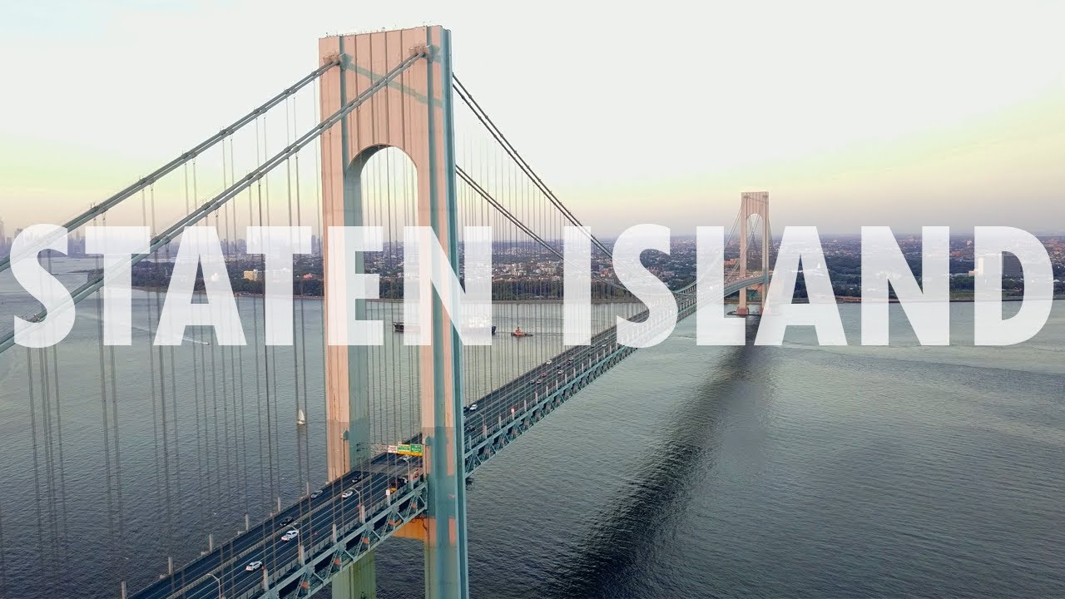

Table of contents

1. Introduction
2. Focus on the feature required by the clients
3. Conclusion

**1.Introduction**

In this project I have to take into consideration a couples' request of finding the best neighborhood among the 62 of Staten Island, which answers their search characteristics.

**The three features** I have to bear in mind, in order of importance, are:

a. the neighborhood needs to have an excellent school

b. the housing price needs to fit their budget and be affordable

c. there should be no venue in the neighborhood that already caters for vegetarians as the couple would like to start their own business and would like to avoid competition.

In this project, I will analyze Staten Island, New York by converting addresses into their equivalent latitude and longitude values and by using the Foursquare API to explore the neighborhoods. I will use the explore function to get the most common venue categories in each neighborhood, and then use this feature to group the neighborhoods into clusters. I will use the k-means clustering algorithm to complete this task. Finally, the Folium library will be used to visualize the neighborhoods in Staten Island and their emerging clusters. Furthermore I will provide a DataFrame with the best schools and the average housing price per neighborhood. The final stage will be identifying the neighborhood that does not have a Vegetarian Restaurant.

2.**Focus on the features required by the clients**

After having analyzed the neighborhoods of Staten Island thoroughly and knowing the area well enough to make recommendations to my clients, I should focus now on their requirements.

* The first one is a good school for their children. This is the clients’ first priority.

Therefore I shall look for information about the best 5 schools in Staten Island.

This will restrict our search tremendously and simplify the process of identifying the best neighbourhoods among the 62.

After many hours of searching the internet for information in a format that can be processed by Python, whether it is .csv, json, etc. I have decided that the easiest way is to create my own Dataframe. This I can easily do with data from www.greatschools.org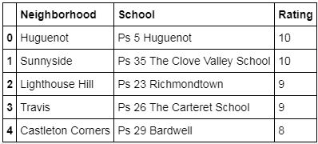

* The second requirement is a reasonable housing price in the range of 250k to 400k¶

Background information for housing prices in Staten Island.

The median home value in Staten Island is $526,000. Staten Island home values have gone up 8.4% over the past year and Zillow predicts they will rise 7.1% within the next year. The median list price per square foot in Staten Island is $385. The median price of homes currently listed in Staten Island is $569,000 while the median price of homes that sold is $465,900. The median rent price in Staten Island is $2,300, which is lower than the New York median of $2,900.

The information necessary for making a dataframe with housing prices can be found on https://www.zillow.com/staten-island-new-york-ny.

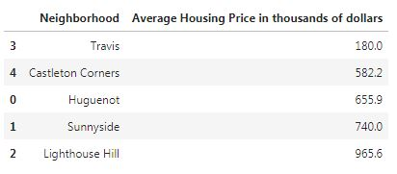

* The third requirement is to find the neighborhood which does not have a Vegetarian restaurant so that the new family can set up their own business.

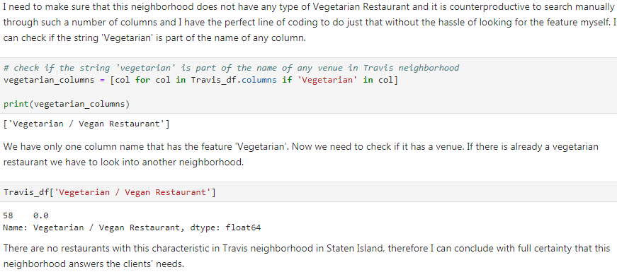

**3.Conclusion**

With all the data analyzed and an obvious conclusion reached I can finally recommend the best neighborhood for buying or renting property in Staten Island according to the desired characteristics.

The three features, in order of importance, that I had to take into consideration were: a neighborhood with a good school, with affordable housing and one that did not already have a Vegetarian Restaurant so that the couple could find a proper dwelling for their young family and also a venue for their business.

As proven in this analysis the best option for our clients is **Travis Neighborhood** due to the fact that it answers fully to the requirements.

And here we are at the end of this presentation.

Thank you for your time and patience!